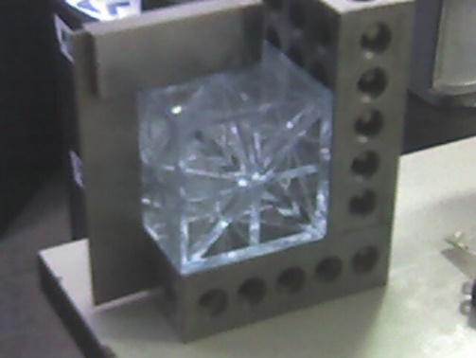

**METATRONIUM**

**The Future of Sustainable Technology**



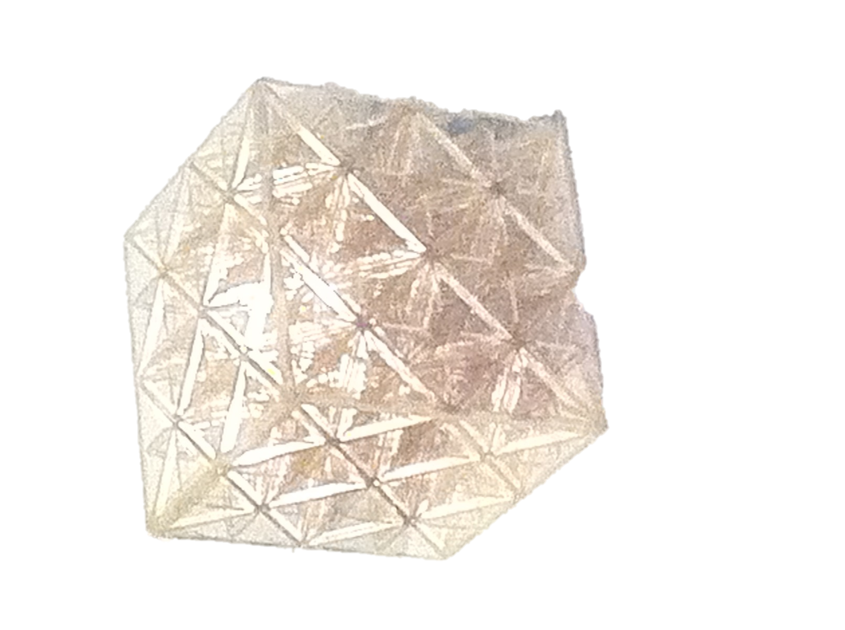**Metatronium is not just a term; it's a vision for the future. It's a metamaterial fabrication technology capable of synthesizing digital topographies while seamlessly integrating subsystem architecture. At its core, it's a platform designed to amalgamate the properties of its constituents by simulating the resting field geometry of the strong force polarization balance, which is responsible for accrued mass in the subatomic realm.**

**In simpler terms, it's a lattice structure defined by seven planes of colinear force distribution. The outcome? A unit cell geometry that offers scalable transmutation capabilities. This innovation holds the promise of recycling all types of manufacturing byproducts, presenting a feature set mirroring the color palette capabilities we see in today's digital displays.**

**This vision was born from a glimpse I had back in 1996, where I foresaw the convergence and miniaturization of technology. I imagined a future where humanity harnessed the tools to achieve unparalleled sustainability. The Onestone vision paints a picture of a closed-loop resource management system in symbiosis with nature.**

**My teenage years were marked by a fascination with physics and engineering. While the miniaturization of high-tech electronics seemed promising, the journey to microscale subsystem integration was daunting. This challenge became my starting point. Armed with this vision, I embarked on identifying the essential attributes for such an architectural marvel.**

**For this dream to materialize, we need a universal framing system, one that offers micro precision and macro accuracy on a city-wide scale. This system should adeptly handle locational data across scales. While the first three dimensions - Length, Width, and Height - are straightforward, the fourth dimension, time, encapsulates them. Einstein's genius gave us this insight. However, the fifth dimension remains elusive, challenging our perceptions. By designing a platform that supports this fifth-dimensional coordinate system, we can embed any location, at any scale, with assembly features. But to bring these features to our realm, we need a bridge, a connector.**

**Enter Metatronium, my brainchild. It stands as a universal calibration lattice.**

**Our planet is littered with resources, either buried in landfills or floating in our oceans. Despite the advancements, our recycling methods remain rudimentary. The key to a sustainable future lies in refining our recycling technologies. Molecular manufacturing technology, in its zenith, can process waste compounds and reintroduce them as valuable resources. Starting with a 2”-unit cell, achieving this precision requires about 28 successful scale drops. To make this leap, we need standardized environments that can halve their original scale in 5D, coupled with system designs equipped with predictable toolsets that resonate with their 5D origin geometry.**

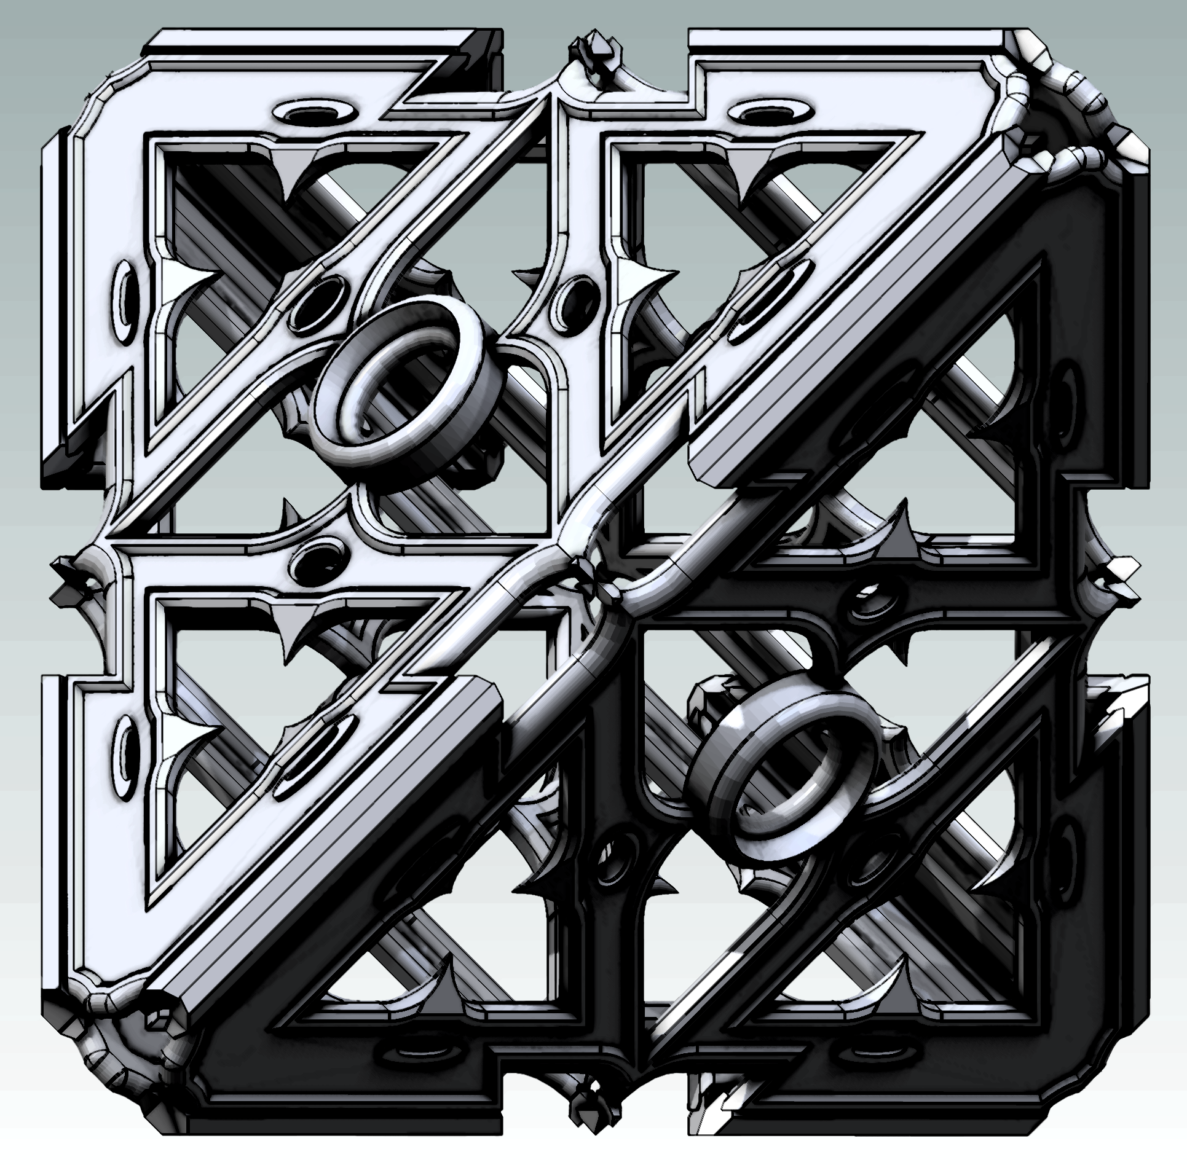**This mission, this dream, is what I term as priority 1.**

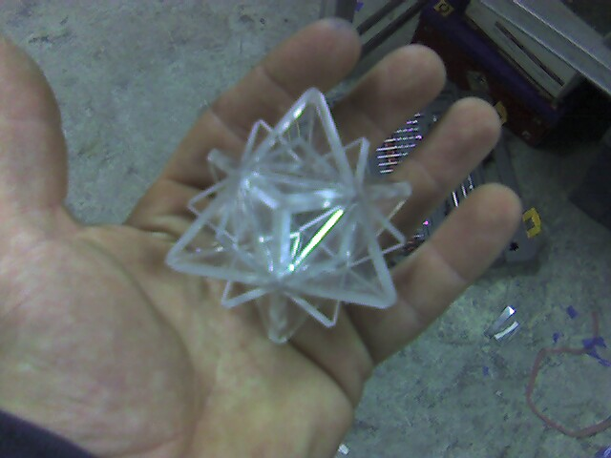

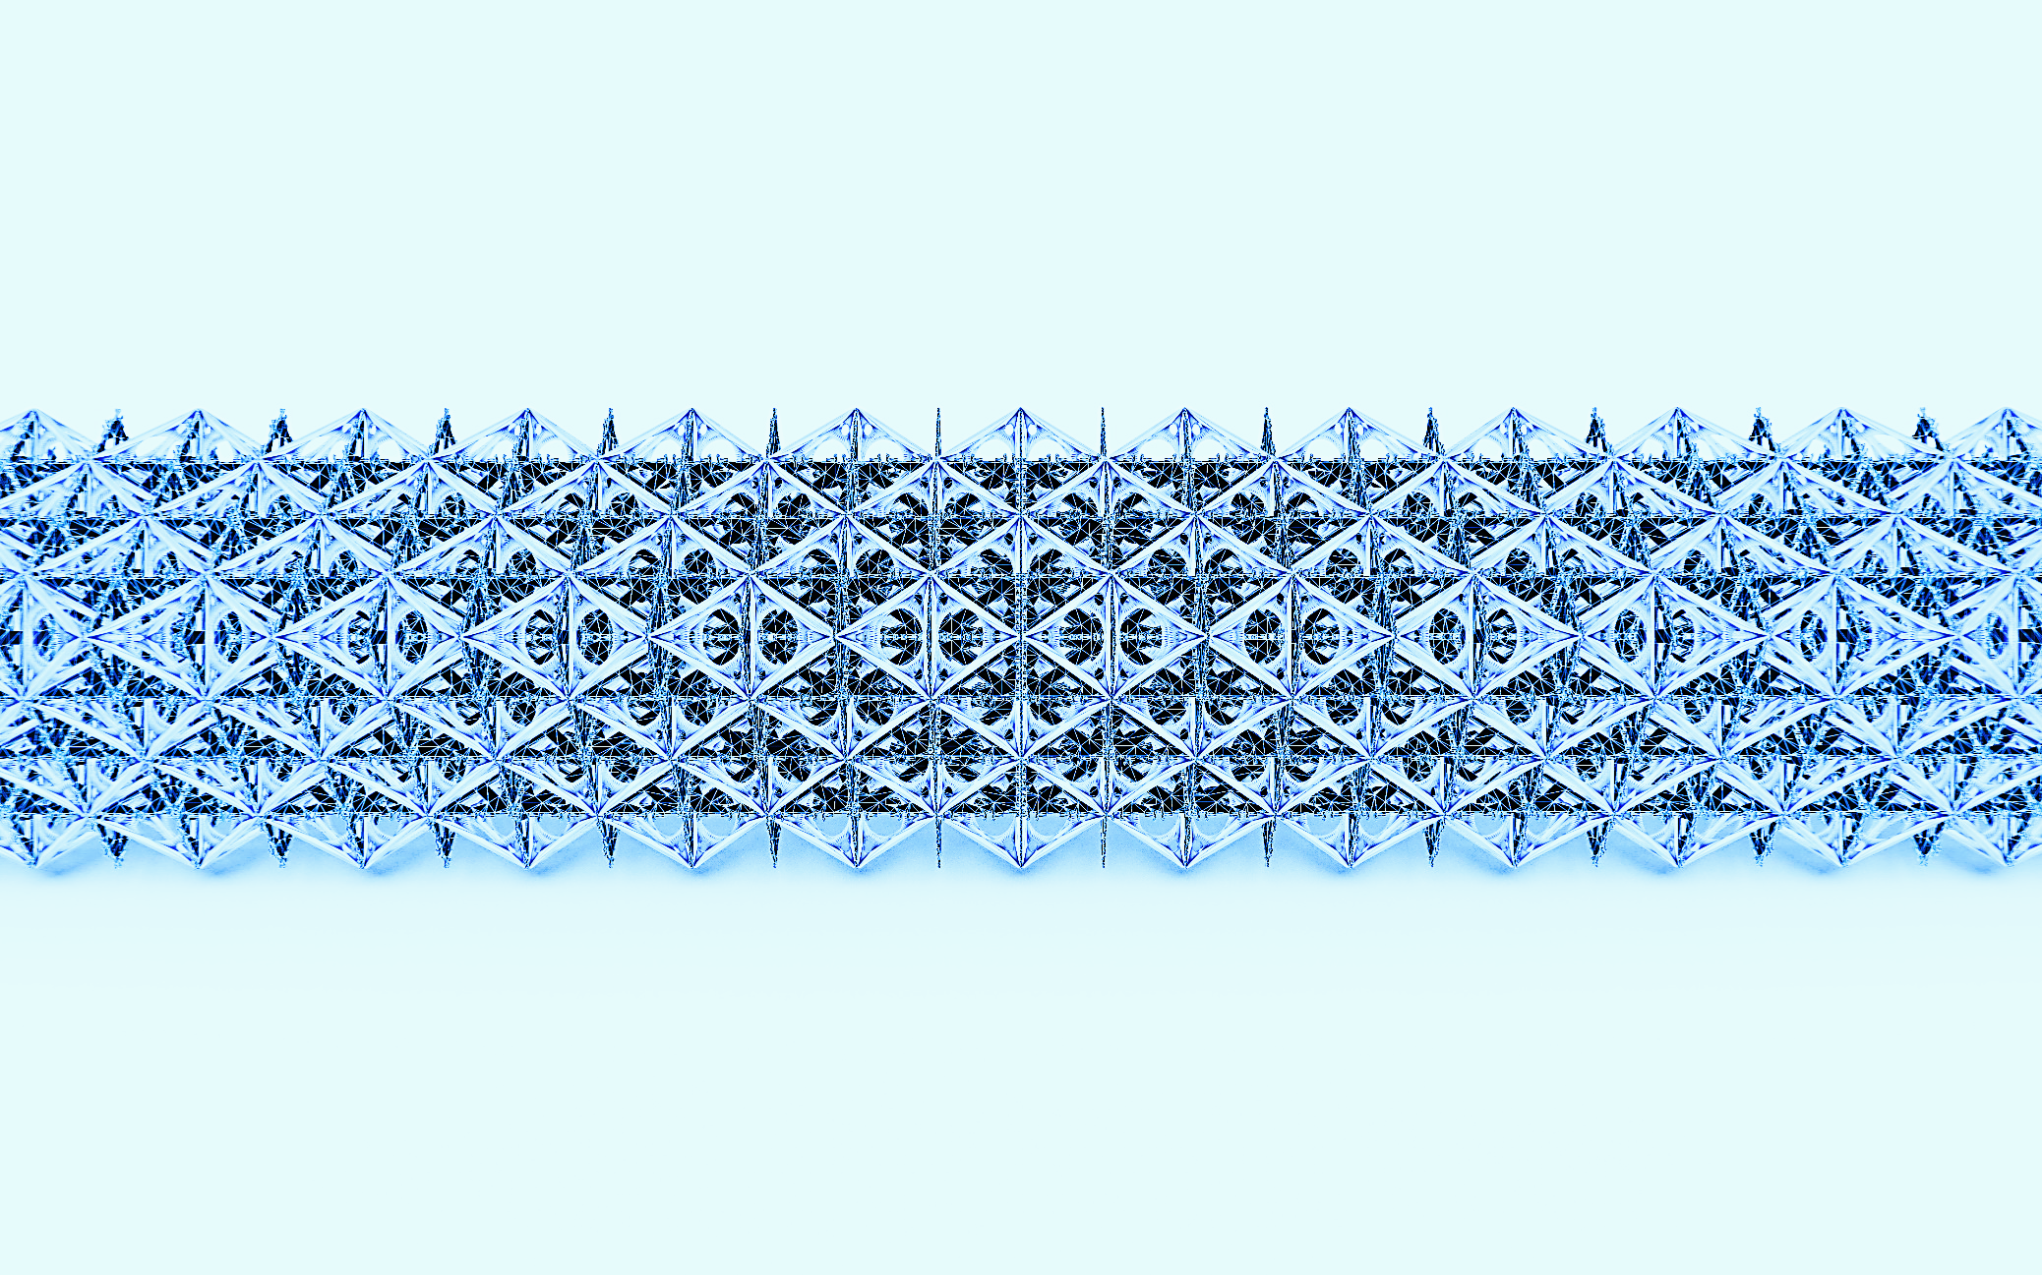



**The idea is a complex, multi-faceted system that aims to revolutionize the way creators and manufacturers interact and are compensated. Here's a simplified summary:**

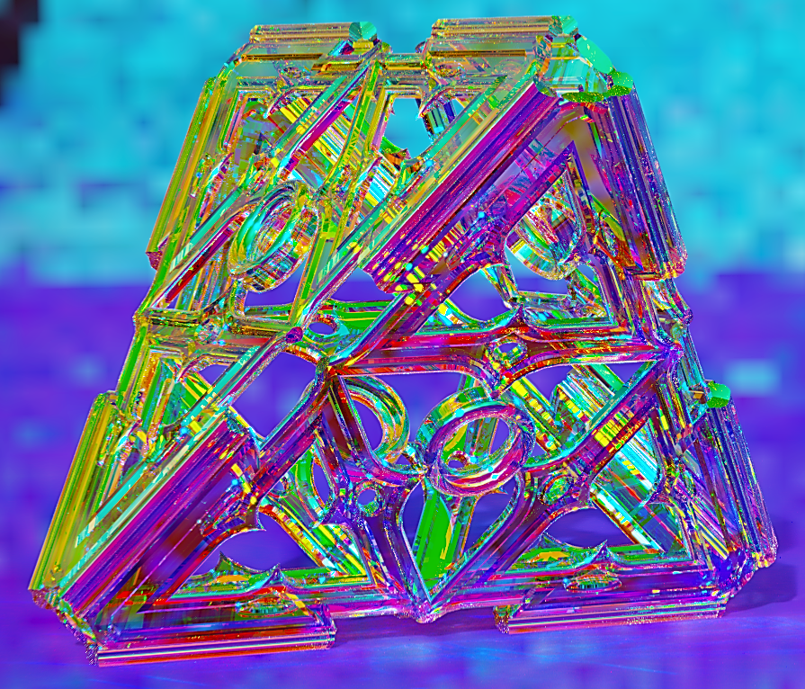

**Concept Overview:**

**Onestone is an educational platform that showcases how people use Metatree. It's designed to feel like a VR MMO video game.**

**Metatree is a digital interface that:**

1. **Provides tools and training for users to design and create.**
2. **Allows users to search for and incorporate virtual materials and parts into their designs.**
3. **Operates on a principle of universal attribution and equity dispersal, ensuring creators are rewarded for their contributions.**

**Key Features:**

1. **Universal Attribution: Every design or creation is attributed to its creator(s). If someone else uses or builds upon that design, the original creator(s) get rewarded.**
2. **Blockchain Integration: All attributions and compensations are recorded on a blockchain ledger. This ensures transparency and security in the system.**
3. **Partnership Model: Everyone involved with Onestone or Metatree is considered a partner. This partnership grants access to the platform and its benefits.**
4. **Eldertech: This is a foundational technology or design upon which others are built. Every subsequent design that builds upon an eldertech gives credit (and compensation) to that foundational technology.**
5. **Remunerative Dilution: This is a system where the compensation for a design decreases as more and more designs build upon it. The idea is that the earliest designs (eldertechs) get a smaller piece of the pie as more layers are added on top.**
6. **Production and Manufacturing: The system also handles the production side. Producers are alerted to new designs, and there's a clear system for calculating costs and profits.**

**Vision:**

**The ultimate goal is to elevate digital manufacturing by fostering collaboration and ensuring fair compensation. By connecting creators and ideas across a network of partnerships, the system aims to streamline the design-to-production process and incentivize innovation.**

**Thoughts:**

1. **Complexity: The system is intricate, which might make it challenging for new users to understand and engage with. Consider simplifying or providing comprehensive onboarding tutorials.**
2. **Blockchain: Using blockchain for transparency and security is a great idea, but ensure that the system can handle the volume of transactions and that it remains cost-effective.**
3. **Eldertech: The concept of rewarding foundational technologies is innovative. However, determining the value of each eldertech might be subjective and could lead to disputes.**
4. **Remunerative Dilution: This system ensures that everyone gets a piece of the pie, but it might disincentivize creators from building on too many pre-existing designs if they feel they won't be adequately compensated.**
5. **Scalability: As more and more designs and eldertechs are added, the system might become cumbersome. Ensure that the platform can scale and remain user-friendly.**
6. **Market Adoption: Convincing creators and manufacturers to adopt a new system might be challenging. Consider a phased rollout or offering incentives for early adopters.**

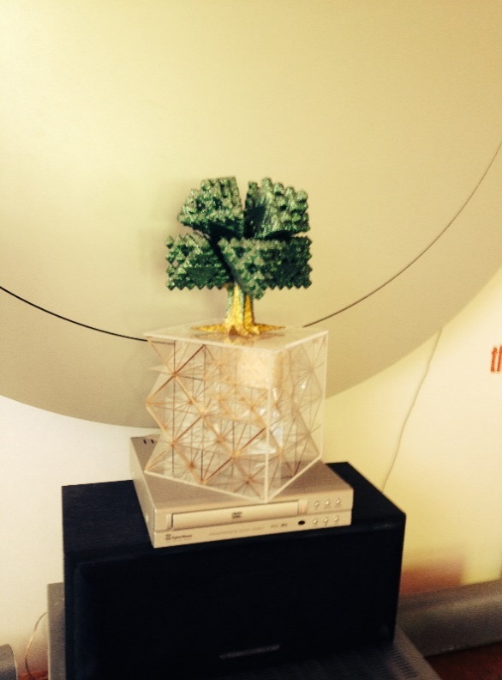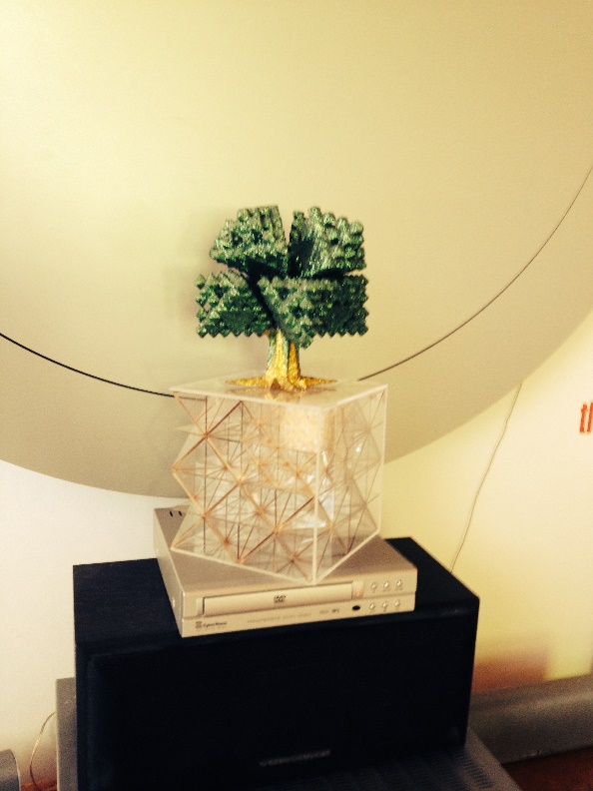**In summary, the idea is ambitious and has the potential to revolutionize the digital manufacturing space. With the right execution and user education, it could become a game-changer in the industry.**

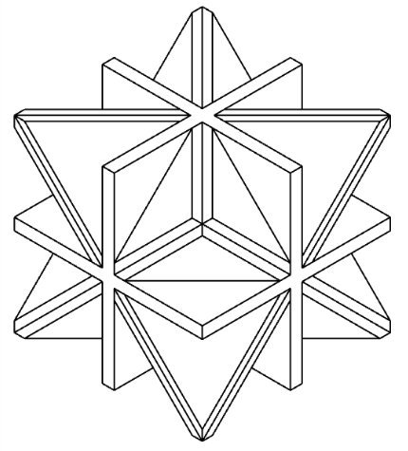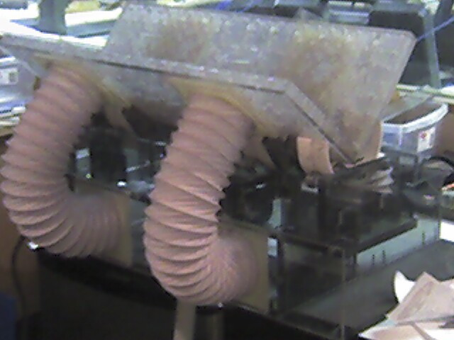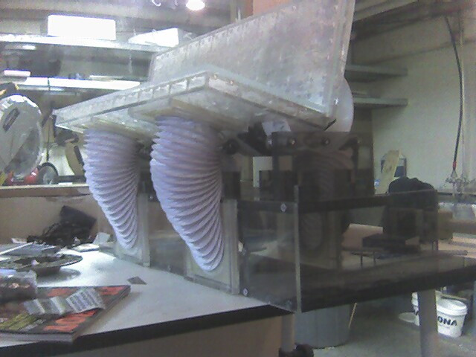@Metatron6942069